X CSC 134 Fall 2008
Homework 3
Total: 300 points
Due: Nov. 18, 2008, at 11:00 pm

This homework allows students to practice the development of a database using Oracle.

Section 1
Using SQL, create tables according to the given schema shown in Figure 1. The ER diagram is shown in Figure 2.

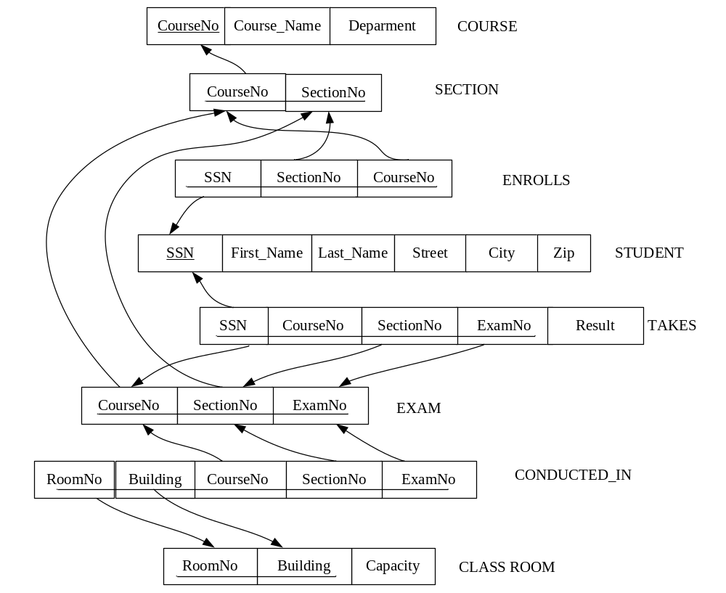

Figure 1 Schema

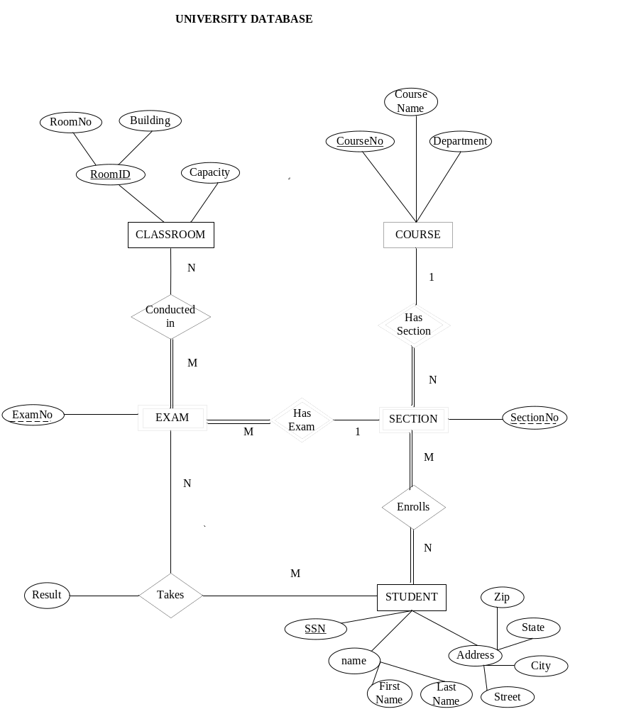

Figure 2 ER Diagram

Section 2
Populate the database. Please check sections 3 for details.

Section 3
Use SQL to specify the following queries. When you populate the database, insert data such that at least one row will be display as the result of running each query.
- ) Retrieve information (SSN, first name and last name) about students who took the course ‘Computer Architecture’.
- ) Get the information (SSN, first name and last name) about students who have taken the course ‘VLSI’. Also get the section number in which they have enrolled in the course.
- ) Get the course names and course numbers which have 2 or more students.
- ) Retrieve the information (SSN, first name and last name) of students who got
Grade ‘A’ in at least two courses.
- ) Obtain information (exam number, course number and section number) about the exams taking place in building ‘Mendoccino Hall’. Along with that get the room’s capacity, room number and its building name.
6) Retrieve information (SSN, first name and last name) about students who are enrolled in both the courses ‘C11 and ‘C21’. (‘C11’ and ‘C21’ are course numbers) (hint: use INTERSECT)
7) Retrieve the courses that have more than 2 sections. (List course name and number of sections)

Section 4
Specify the statements to drop all the tables. Pay attention to the order of the drop statements in order to drop everything successfully.

Submission

Submit the following files. Please wrap these files into a “zip” file and then submit it to WEBCT. Make sure the files can be unzipped in Windows XP for grading.
- Create table statements (file name must be: 1_create_table.sql)
- Insert statements to populate database (file name must be : 2_populate_db.sql)
- Queries (file name must be: 3_query.sql)
- Statements to drop all tables (file name must be: 4_drop_all.sql)
- An output file showing query results (file name must be: 5_output.pdf, or 5_output.doc, or 5_output.txt). In this file, for each query, you must:
  - Include the number and query description (e.g Query 1: Retrieve information …)
  - Your SQL query (e.g. select… from…)
  - The result of running this query.

